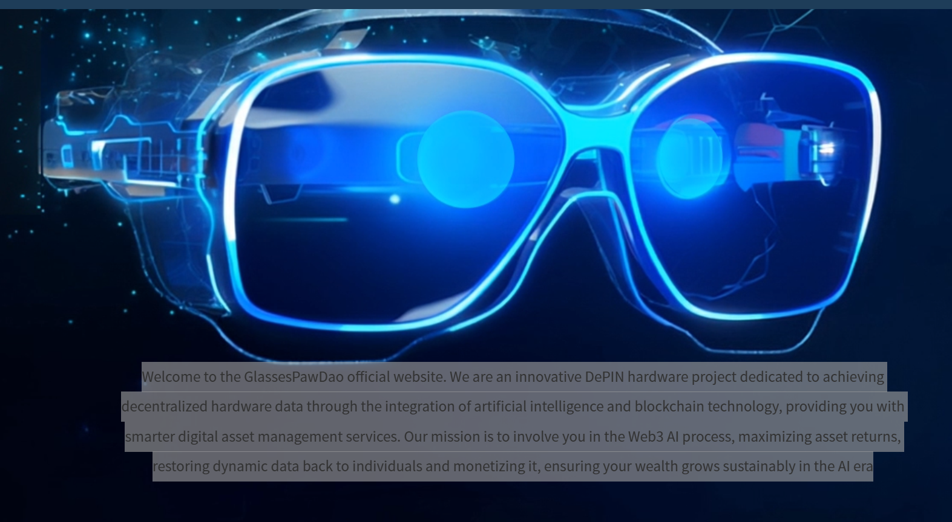
Welcome to the official GlassesPawDao website.
We are an innovative DePIN hardware project dedicated to decentralizing hardware data through the integration of artificial intelligence and blockchain technology. Our platform provides smarter digital asset management services while empowering you to participate in the Web3 AI ecosystem.
Our mission is to maximize asset returns, return control of dynamic data to individuals, and enable its monetization—ensuring your wealth grows sustainably in the AI era.

AI-powered financial management with no loss of principal, transparent smart contracts, multi-layer AI audits, and secure, reliable guarantees — all while generating value-added income.
Will you be part of it?

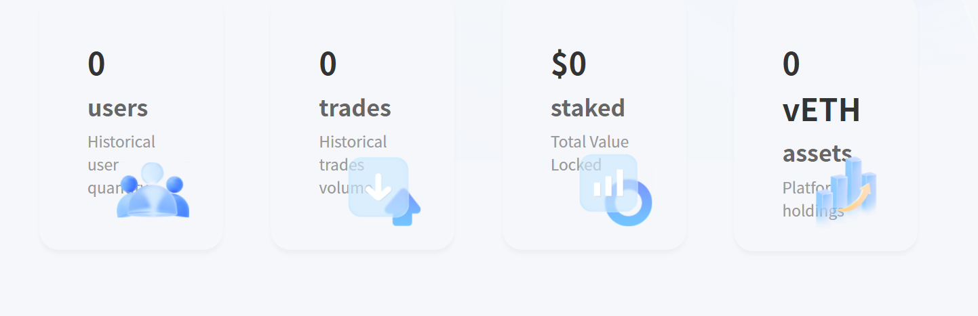
这个拿掉要么放真实数据，不可以放零，中英都得改

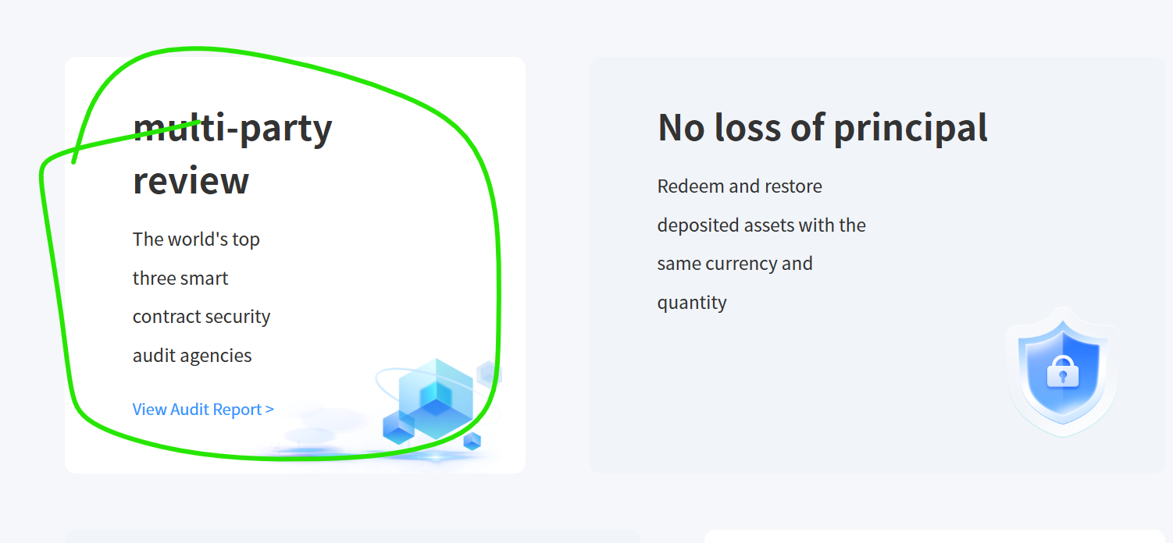
这个，链接不行啊
点了过后回到主页
拿掉吧
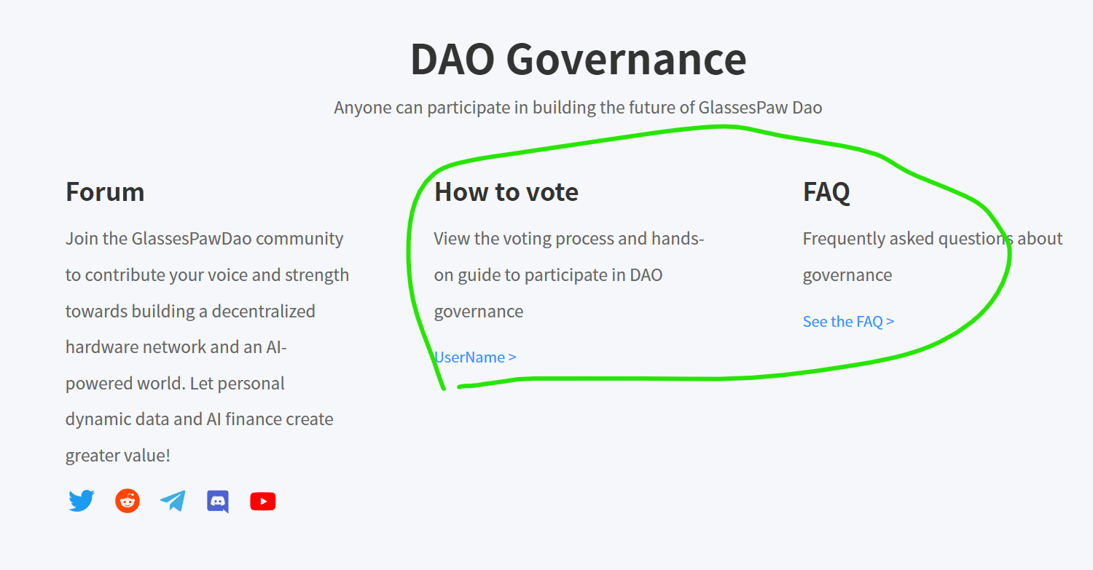
这两个也拿掉
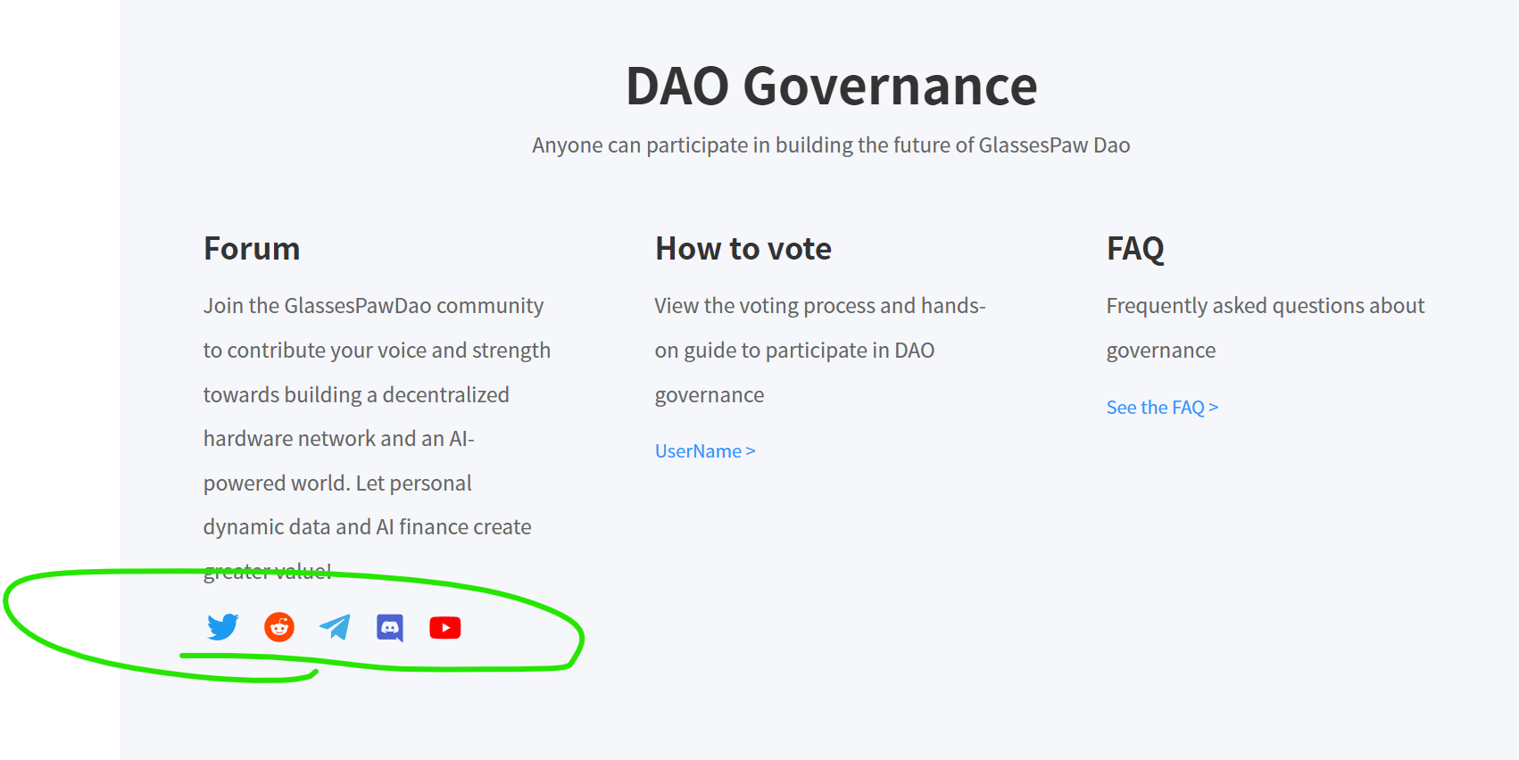
Twitter我们有对吧，把它连接好
剩下的没有就拿掉

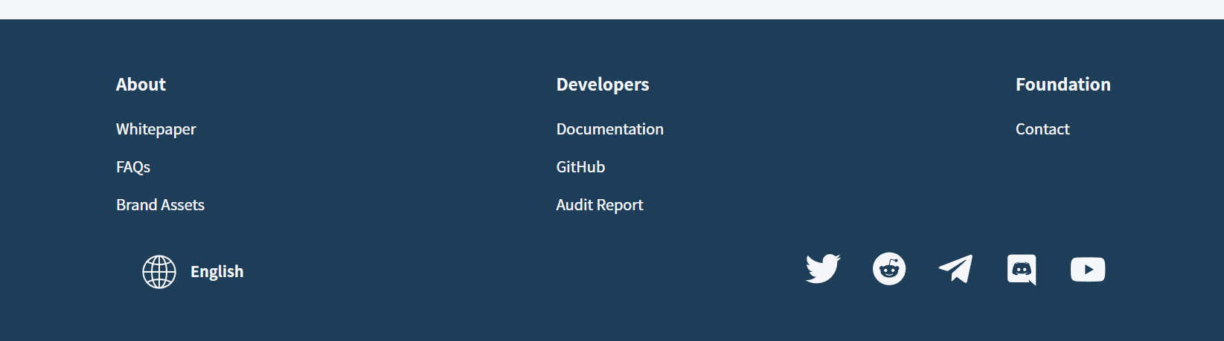
这边一样，有的才放，没有的全部拿掉

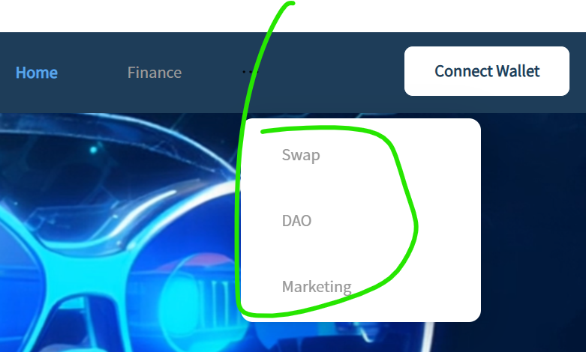
这边一样，有的才放，没有的全部拿掉

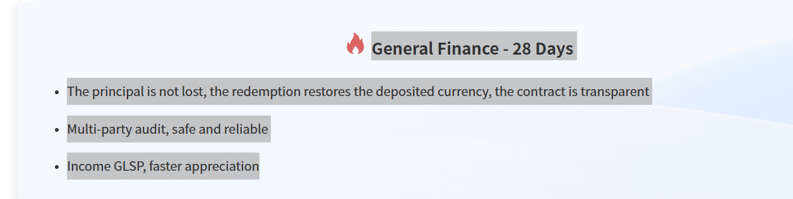
General Finance – 28 Days
Your principal is fully protected, and upon redemption, you receive your original deposited currency.
The contract is transparent, backed by multi-party audits for safety and reliability.
Earnings are distributed in $GLSP, with faster potential for appreciation， due to increase in demand for the GlassesPaw Eyecare Device and it’s corresponding herbal solution, which can only be paid for, in $GLSP.

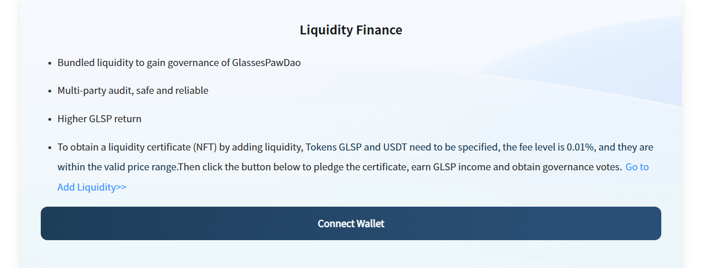
Liquidity Finance
Bundle liquidity to participate in the governance of GlassesPawDao.
Earn higher returns in $GLSP.
By adding liquidity with GLSP and USDT, you will receive a Liquidity Certificate (NFT). The fee level is set at 0.01%, and positions must remain within the valid price range. Simply click the button below to stake your certificate, start earning $GLSP rewards, and gain governance voting rights.

